Day 1 – 16/05/2025

Q1. What is SDLC?  
Ans. SDLC is process followed to develop software. It is used to ensure all the requirements like standards, quality and user expectations are met. It involves several phases like plan, design, develop, test and deployment. Some of the known SDLC models are waterfall, V-model, agile, iterative etc.

Q2. Why SDLC?   
Ans. SDLC helps to give a proper and clear path to approach our project completion. Without SDLC projects can be made but it won’t be as simple as an SDLC project. There is a high chance of project deployment getting blocked/delayed by several aspects like requirements misunderstanding, unmanaged risks and poor quality.

Q3. What are the stages of SDLC?  
Ans. SDLC stages:

1. Plan – Define project scope, goals, timelines and resources
2. Analysis – Gather requirements, user needs and create a detailed specification.
3. Design – Create a detailed design plan, including architecture, components and interfaces.
4. Implementation – Write code, build the software and conduct testing.
5. Testing – Perform various types of testing and fix any bugs if found.
6. Deployment – Launch the software to users.
7. Maintenance – Provide real time support, updates and bug fixes.

Q4. What are the SDLC models?  
Ans. SDLC models:

1. Waterfall model – Development and testing are sequential. Suitable for smaller projects.   
   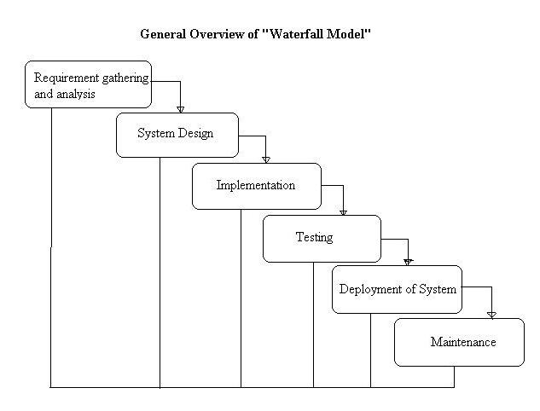  
   Applications: Banking systems and Government websites – well defined requirements, strict regulations and limited scope.   
   Advantages:
2. Clear and defined process
3. Predictable timelines
4. Easy documentation
5. Focus on upfront planning

Disadvantage:

1. Inflexible to change.
2. Limited user feedback
3. Errors may go unnoticed
4. Not ideal for complex projects
5. Verification and validation model – An extension/variant of waterfall model.   
     
   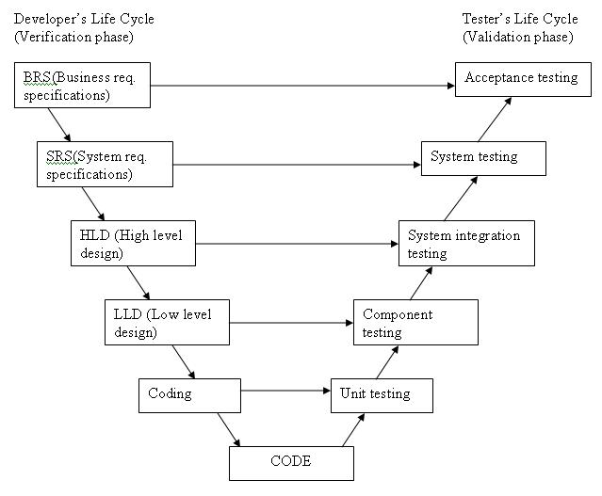  
     
   Applications: Aircraft control systems.  
   Advantages:
6. Early defect detection
7. Structural approach
8. Improved quality
9. Clear documentation

Disadvantages:

1. Inflexible
2. Limited user input
3. Overkill for simpler projects
4. Rework potential
5. Iterative model – Rapid prototyping, uncertain/evolving requirements. Early user feedback. Suitable for complex projects.   
     
   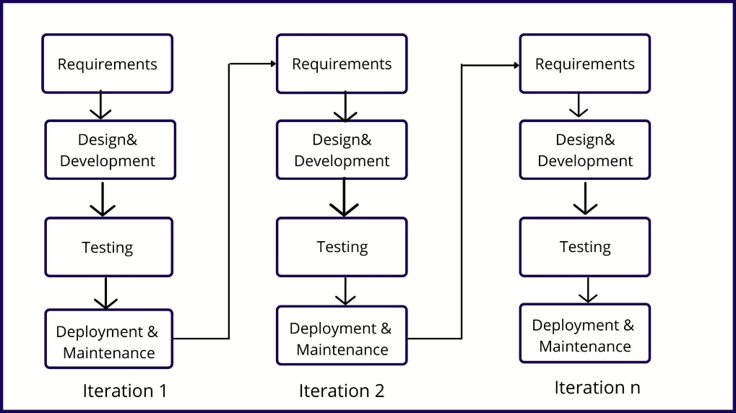  
     
   Applications: Game development  
     
   Advantages:
6. Adaptable to change
7. Early user feedback
8. Reduced risk
9. Improved quality

Disadvantage:

1. unpredictable timelines
2. increased management overhead
3. Highly skilled resources
4. Not ideal for simple projects
5. Agile model – Agile is an incremental model with rapid cycles, delivering small releases that build on previous functionality. Suitable for projects with tight deadlines. 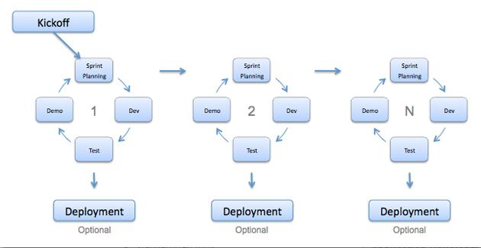  
   Applications: Mobile app development.

Advantages:

1. Flexibility
2. Iterative progress
3. Customer feedback and involvement
4. Improved quality

Disadvantages:

1. Unclear or changing requirements
2. Requires more planning, coordination and communication.
3. Estimating project timelines and costs can be challenging.

1. Spiral model – combination of iterative and incremental development. Suitable for projects with high risks and uncertainties.  
     
   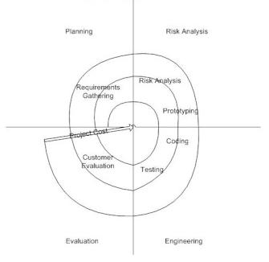

Applications: Financial systems – requires high risk management.   
Advantages:

1. Risk management
2. Additional functionality can be added at a later date.

Disadvantages:

1. Complex and difficult to manage.
2. May requires more resources and investment.

Q5. What is scrum?  
Ans. Scrum is a framework within agile used for managing and completing the projects by breaking down complex projects into smaller, manageable pieces.

Q6. What is sprint?  
Ans. Sprint is a short period during which a specific amount of work is completed.

Q7. Dos and Don’ts of sprint.  
Ans. Dos:

1. Set clear goals
2. Encourage collaboration
3. Prioritize tasks

Don’ts:

1. Overcommit
2. Change goals mid sprint
3. Ignore feedback

Q8. Define backlog and story.  
Ans. Backlog – is a prioritized list of features, requirements or tasks.  
 Story – is a brief description of a feature or requirement from users’ perspective.

Q9. Brief the scrum artifacts.  
Ans. Scrum artifacts are tools used to manage and track progress in projects.

1. Product backlog – A prioritized list of features, requirements and tasks.
2. Sprint backlog – A list of tasks to be completed during a specific sprint.
3. Increment – The working software delivered at the end of a sprint.
4. Burndown chart – A graphical representation of the amount of work remaining in a sprint or project over time.

Q10. What are ports and protocols?  
Ans. Port – a number assigned to a specific process or service running on a computer. Ports allow multiple applications share the same IP address.   
Protocol – a set of rules governing data communication between devices. Protocols ensure reliable and efficient data transfer.

Q11. What are the different network types?  
Ans. Local Area Network (LAN), Wide Area Network (WAN), Metropolitan Area Network, Wireless Local Area Network (WLAN), Virtual Private Network (VPN).

Q12. What are the types of servers?  
Ans.

1. DNS server – Resolves domain names to IP addresses.
2. Web server – Hosts and serves websites.
3. Database server – Manages and stores data in databases.
4. DHCP server – Assigns IP addresses to devices.
5. Mail server – Manages email services.
6. File server – Stores and manages files, provides file sharing.

Q13. What do you know about DNS?  
Ans. DNS helps users to access websites and online services using easy to remember domain names. Converts human readable domain names to IP addresses.

Q14. What are different types of network topologies?  
Ans.

1. Bus topology – Devices are connected to a single cable. Simple, cost-effective, but vulnerable to the cable failure.  
   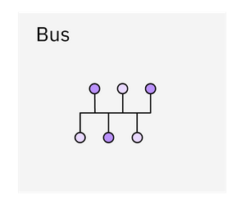
2. Star topology – Devices are connected to central hub/switch. Scalable, easy to manage and fault tolerant.   
   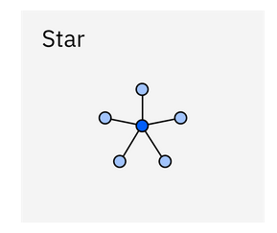
3. Ring topology – Devices are connected in a circular configuration. Suitable for hi-speed networks, but vulnerable to single point failures.   
   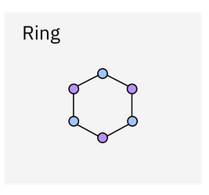
4. Mesh topology – Each device is connected to every other device. Highly reliable, fault tolerant, but complex and expensive.   
   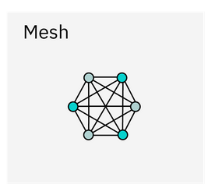
5. Tree topology – Combination of bus and star topologies. Scalable, easy to manage and suitable for large networks.   
   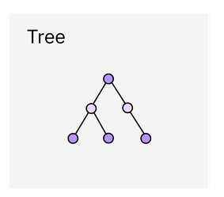
6. Hybrid topology – Combination of two or more topologies. Flexible, scalable and suitable for complex networks.   
   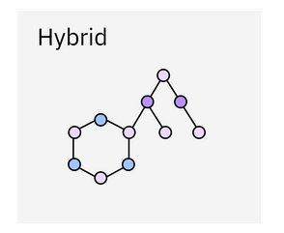

Q15. What is OSI model?  
Ans. Open Systems Interconnection (OSI) model is a 7-layered framework for designing and implementing computer networks.

1. Physical layer – physical means of data transmission. Ethernet cables, Wi-Fi, fiber optic cables. Bit-level transmission, cable specifications.
2. Data link layer – ensures error free transfer of data frames between nodes. Framing, error detection and MAC addressing.
3. Network layer – routes data between networks. Logical addressing, routing.
4. Transport layer – ensures reliable data transfer. TCP, UDP. Segmentation and reassembly, reliable data transfer, flow control, error detection and correction.
5. Session layer – establishes, manages and terminates connections. NetBIOS, SSH. Session establishment and termination, sync and dialogue management.
6. Presentation layer – converts data into a format understandable by the receiving device. SSL/TLS, MIME. Data compression, encryption, formatting and character set translation.
7. Application layer – provides services and interfaces for applications. HTTP, FTP, SMTP. Supports functions like email, file transfer, web browsing. Enables communication between applications.